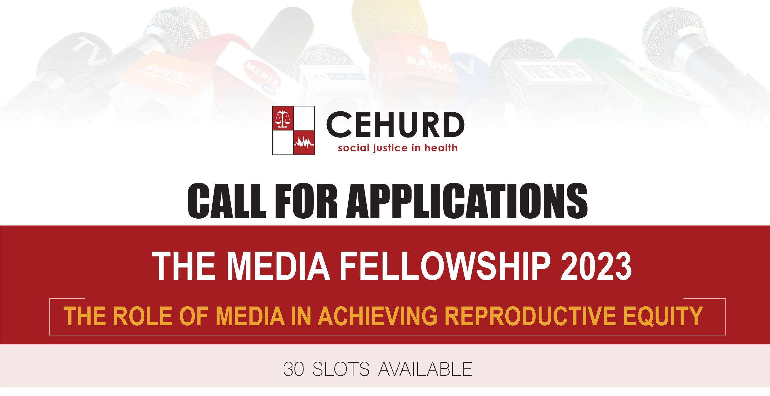

Please make sure you have fully read the application criteria below before you begin completing this form.
Applicants must complete all the sections of the form: Please note that all applications must be completed in English. Any incomplete or illegible application will not be considered for the fellowship.
Please note that small grants will be provided to selected journalists to conduct investigative stories on SRHR issues. These stories will be in form of either documentaries, publishable articles or spot messages, Radio/TV shows or any other form. These small grants will be awarded through a competitive process where journalists on the programme will develop and submit a proposal based on an innovative/creative idea with potential to impact on policy makers, other duty bearers and/or the population.

Application Criteria
Applicants must have:
- A minimum of a diploma in journalism, development studies, social sciences, development communications or any other related field
- Experience of at least two years in journalism, practicing with an established media house
- Recommendation letter from the editor or producer.
- Interest in developing a career path in sexual and reproductive health and rights reporting for young people
- Must NOT have participated in any past CEHURD SRHR media fellowships

Section One: Applicants’ details
Mr., Mrs., Ms, Dr.
Full Name:

Job Title:

Years of Experience:

Qualification (Attach scanned copy of certificate, transcript or both)

Previous Education on Sexual Reproductive Health and Rights (If yes please mention):

Email Address:
Section Two: Institutional details
Institutional Name for current employer:
Address:
District:
Country:
Telephone:
Fax:
Website (if applicable):

Short Description of your institution (Max 150 words)
Section Three: Your motivation to apply for the fellowship
Outline four reasons why you want to be enrolled on this media fellowship programme on SRHR:

What is your experience reporting on issues of SRHR, if any? (150 words maximum)

How will you use the knowledge and skills you will gain from the fellowship programme? (150 words maximum)

Why are you the right person to be considered for the fellowship programme? (100 words maximum)

Section Four: Application support/endorsement
This application must be endorsed by your current supervisor in your current institution of work. Please provide details of the person supporting the applications below.
Mr., Mrs., Ms., Dr.
Name: Mr,
Job title/role in the institution:
Email address:
Telephone:
The person supporting the application must say in no more than 100 words why it is important that you are enrolled on the fellowship programme:

Signature:

Stamp:

Applicant Statement

Please read the following statement and enter your name at the bottom to confirm that you accept the terms and conditions of the fellowship programme.

I confirm that to the best of my knowledge the details in this application form are correct.

I understand that if it is not correct, appropriate action may be taken, which may lead to no further such fellowship and/or partnership opportunities being awarded to my institution and I will ensure that the knowledge and skills obtained from the programme are put to good use, as well as ensure that any funds which may be received to support the achievement of the fellowship goals and objectives will not be misused or misappropriated in any way.

In the event of any situations which would interrupt my attendance, participation and completion of the programme, I will immediately inform CEHURD and I understand that I may be liable to return any funds which may be received under this fellowship programme if it is not used for the purposes for which it is given. I understand that the information provided in this application will be used by CEHURD for the processing of the application, and may also be viewed by a third party (i.e. funder) if appropriate and may be used for education, advocacy and resource mobilisation purposes.

Once the application has been submitted with all the required supporting documents, we will aim to let you know the outcome of your application within 1 week after the deadline.

If your application for the fellowship programme is successful, then CEHURD will inform you and request for your bio for communication purposes

I, also, understand that all fellowship recipients are required to provide a testimonial to highlight the benefits derived from the fellowship programme. This can be a video or written testimonial.

- I accept the conditions of the applications (please tick box)

Please submit your application form and academic credentials plus any questions to: info@cehurd.org and copy nabunya@cehurd.org

